Person Centred Planning & Circles of Support
Overview and information Sheets

Compiled by Lynne Elwell

The Term Person Centred Planning refers to a family of approaches to organizing and guiding community change in alliance with people with disabilities and their families and friends.
Whatever your place in the person’s life it is vital that before you start planning with someone else, you plan for yourself. Completing our own plans first, is the beginning of the learning process in person centred planning.
If you want to learn to facilitate plans it is important to learn about all the planning styles, in person centred planning and see the difference to traditional planning. And discover that when the right ‘tool’ is used and the person is really listened to dreams really do come true.
The purpose of Person Centered Planning is learning through shared action. People who engage in Person Centered Planning may produce documentation of their meetings, proposals, contract specification, or budgets. These are only footprints: the path is made by people walking together.

The focus person and those who know the person best may be uncertain about what is possible or desirable for the person. One function of Person Centered Planning is to decrease such uncertainty by encouraging people to try new things together and to learn from them.

Each approach to Person Centred Planning has distinctive practices, but all share a common foundation of beliefs:

- Personal Futures Planning (O Brien 1987)

- MAPS (Forest and Snow 1987; Vandercook and York, 1988)

- Circles of Support (Pearpoint ‘Joshua Committee’
and N. W. Circles)

- Essential Lifestyles Planning (Michael Smull)

- PATH (Pearpoint, O’ Brien and Forest 1993)

All Person Centred Planning processes share a number of key characteristics:

- the focus is on the person and their life - not to discuss the difficulties the services or the constraints that the service providers might be experiencing due to resources or staffing etc

- the person and the people who love, like and know the person are the primary authority
- the service providers should be present and part of the meeting to provide advice, knowledge, support and service - but remember to be on tap not on top, its not their meeting
- the control is with the focus person and their advocates - when an issue or point has been discussed it should be checked out with the focus person.
- Every aspect of a person’s life is important - universal needs are as important as medical needs
- the focus is on gifts and aspirations, not individual needs and deficiencies
- there is a commitment to address conflict openly and honestly
- there is a commitment to reach a consensus for action

- there is respect for each person’s expertise, knowledge and contribution
- there is a willingness to come up with non-traditional solutions
- time spent should be at a pace that the focus person is comfortable with
- the venue for the meeting should be valued and comfortable for everyone, not necessarily a service setting

An Overview of the various approaches:

PERSONAL FUTURES PLANNING...

In personal futures planning John O’ Brien describes a systematic process of drawing out, and working towards, a desirable future with the person who is at the centre of the plan. A group of people spend time with the focus person in order to develop strategies that will help to plan their future.

They explore:

What is happening at present?

Are there any planned changes that with influence the quality of the person’s life?

What are the threats and opportunities that might influence the future plans?

What would a desirable future look like?

O’ Brien John (1987) A guide to Lifestyles Planning

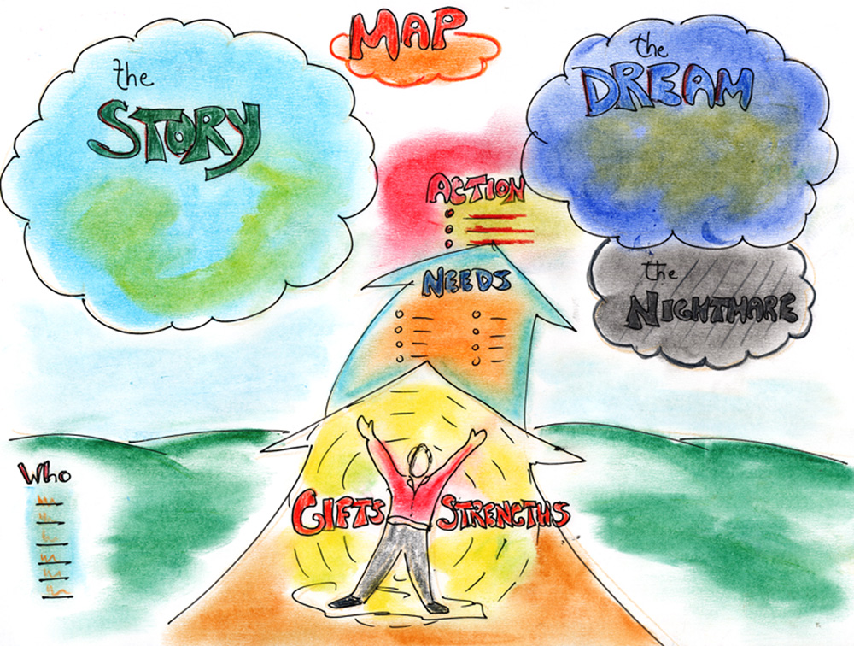

MAPS
MAPS were specifically designed to facilitate the inclusion into mainstream education of young people with disabilities. The process is now used more widely outside the educational environment.

The MAPS planning process usually takes 2-3 hours, participants, the person and those close to her/him, sit around the facilitator who records the ideas generated from eight set questions. These questions are:

What is a MAP? A map is something that gives directions, each member of the group, describes how a map is useful and what it means to them. e.g. a verbal description of how to get somewhere, turn left at the post box etc. Or a very detailed diagrammatic representation of a particular geographical area showing roads, towns etc.

What is the person’s story? This information comes from a discussion of
the persons milestones and significant events. This often brings surprises to others at the meeting.

What is the person’s dream? This is central to the MAPS process. The group spends time-sharing with the person, in describing ‘what the future would look like if it was just as good as it could be’. Others can contribute ideas with the person’s permission, people ‘describe their dreams in lots of different ways, sometimes using images or metaphors to describe their aspirations.

What would the nightmare look like? Naming the nightmares, gives the group something to work away from. This can be a painful and difficult step, but can help each individual to express their fears, and keep the group focussed on aiming for the dream.

Who is the person? The group offer words that describe the individual, there are no right or wrong words, each member of the group is encouraged to take a turn. This can be the first time that the person and their family hear positive and affectionate things said about them. And can be very affirming.

What are the person’s strengths, gifts, and abilities? The facilitator invites the group to describe the things that draw them to the person, a very different process than identifying a person’s problems and disability.

What does the person need, to avoid the nightmare and achieve the dream? The group looks at what resources might be needed.

Action Plan - What are the next steps?
The steps don’t need to be taken in any particular order, sensitivity and imagination is needed. For example if the person’s story is very traumatic, a history of segregation and loneliness, then it would not make sense to move onto the nightmare, the meeting should be a joy, lifting people’s spirits and leaving the person feeling hopeful about their future.

Problem Solving using Solution Circles

Why
To give participants a chance to practice one problem solving technique

How
One participant volunteers to share a problem that they are trying to solve with the rest of the group. The problem should be something that the person is really finding difficult to deal with, some form of dilemma – it should not just be a request for information or an opportunity to ‘just have a moan’.

Ground rules for the group

The person who is sharing their problem should be respected for being open, honest and for trusting the rest of the group. They have agreed to share something that they see as a problem, the group’s jobs is not to judge but to listen and then try and help.
When you are listening to the person describes their problem, do not be judgmental, do not give advice, or belittle anything that they say.

Stage 1
The problem holder chooses 6 people from the large group to help them with their problem. They then have 5 minutes to tell the helpers about the problem they are struggling with. Without interruption,

Stage 2
For five minutes each one of the 6 helpers offers a solution in turn, it does not matter how wild or wacky the solution might seem, Someone writes up the solutions on a flipchart.

Stage 3
The problem holder chooses the top 3 solutions that appeal to them the most. Discusses them with the rest of the group and decides which ones to take forward.

Essential Lifestyle Planning...

‘our quality of life everyday is determined by the presence
or absence of things that are important to us
- our choices, our rituals’
Michael Smull

Essential Lifestyle Planning was developed to assist people moving from institution into the community. Very little is known about some people who use services, particularly those who have lived for a long time within an institution, and those who don’t use words to communicate.

Essential Lifestyle Planning helps to discover and document fine details about a person’s likes and dislikes. This is particularly useful when a person moves from one place to another, it can help to build a team of people around an individual, and can help safeguard a person’s future. It can also provide a basis for an individual service agreement.

This is prioritised into three sections originally described as
Non-negotiable -
Strong Preferences -
Highly desirable-

The information is gathered about the person by ‘interviewing’ those people who know the person best, building up a picture of what a really good day is like, what makes them happy, what makes them angry or sad.

Non- negotiables are what the person must have.... and must not have....

Strong preferences are what the person should have ... and should not have...

Highly desirables are what the person likes..... does not like....

In addition to sorting the information it is important to quantify frequency and volume e.g. they must see their Mother every week.

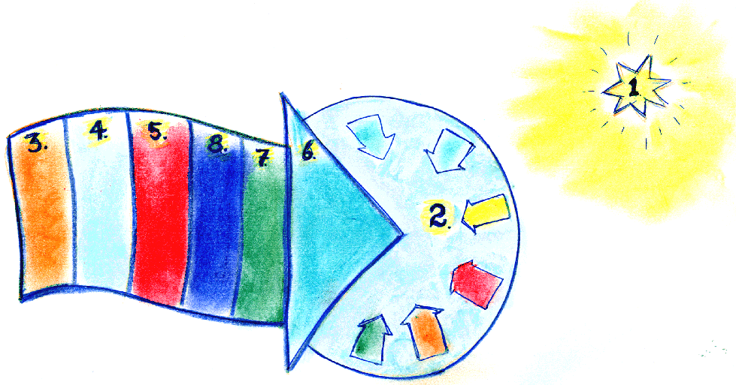

P.A.T.H

Planning Alternative Tomorrows with Hope...

P.A.T.H was developed by Jack Pearpoint, Marsha Forest and John O’ Brien.

PATH is an extremely powerful tool which creates dynamism of its own. It is a facilitated process that provides a structure and safe environment in which to explore dreams and develop plans and strategies to make them come true. The process is recorded on a prepared graphic format. The guiding principles are that any goals must be positive and possible.

Step 1: TOUCHING THE DREA - the North Star
Dreams/aspirations the facilitator asks participants to dream elaborating on their personal vision for the future. This step guides and gives directions to the rest of the PATH

Step 2: GROUNDING THE DREAM
The next step demands that participants imagine that time has passed , usually a year at the most 2 years has passed and that they are back in the same room recollecting what has happened. They tell the facilitators what events have taken place and what they have done working towards making the dream more of a reality. there are two rules to this stage - all goals recorded have to be both positive and possible

Step 3: NOW
Step 3 examines the situation now and analyses the tension between where the group is now and where they want to be in a years time.

Step 4: WHO’S ON BOARD
None of the goals are achievable unless the group work together. Step 4 looks at who needs to help. This could be people at the meeting but also those who are not present. Sometimes individuals who could stand in the way of the goals are identified. Sometimes people who are able to help make the goals come true but who are not at the meeting are identified. Their names are recorded so that a strategy can be developed for winning them over or including them in the plan.

Step 5: recognising ways to BUILD STRENGTH
This can be a very important step in identifying what the group will need to do in order to maintain their strength and commitment to the goals. sometimes it can be as simple as meeting regularly and supporting each other by phone.

Step 6: THREE/SIX MONTH GOALS
The facilitator asks the group to pick a date within the next year normally either three or six months and to set interim goals.

Step 7: FIRST STEPS
First Steps are identified at least one for each person at the meeting.

PATH needs to be used with care. It works best when there are a committed group of people who want to make change happen. Using the PATH process enables people to take control over this change.
PATH is useful when a situation is complex and will require concerted action, engaging other people and resources, over a longish period in order to make an important vision real.

PATH is a way for diverse people, who share a common problem or situation and its possibilities for hopeful action...their action for change, mutual support, personal and team development and learning.

I looked into Annie’s eyes this morning
Mike Green

There is a saying that if the only tool you have is a hammer then the whole world looks like a nail.

Mike: I wrote this poem after two weeks of being in an inclusive community where gifts and differences were valued. When I first met my daughter after this experience I was struck by how differently I experienced her.

Saturday morning

I looked into Annie’s Eyes this morning-
In this morning I looked in Annie’s eyes. My daughter’s eyes. I searched for what was wrong. What is her disability? As I looked in her eyes, at her hair blown by night’s tossing and turning, she smiled and smiled. My heart hurt with sensations all over. Where is it? I could find no wrong with Annie in her beauty playing with her dog this morning.

Polly danced and barked, Annie sprayed water at Polly’s barks. They danced around the room. I felt like I was coming through a thick fog this morning. I cannot see anything wrong with Annie. I cannot feel any where in my body that tight almost nauseous feeling I always have when I think I have seen what’s wrong with Annie.

In this morning my body feels no tightness, no nausea as I look, and look at Annie. She is simply a beautiful joy filled child having morning spraying love and water at her barking dog. Polly.
I sit this morning feeling a trembling in my belly. How precious is this moment of me seeing Annie as she is.

I am angry for all the labellers who have sought to steal my daughter’s life.
I am sad that I have so many times taken their lies inside me seeing Annie as retarded or organic brain damage or disabled or whatever. I have often seen my child with eyes of guilt and shame. I have been robbed of the present.
It is so obvious at this moment that there are only children. People filled with gifts and possibilities.
I feel my belly calm, warm, my heart trembling my eyes with tears, my smile soft. I see Annie so clearly this moment of dog spraying laughter I know I do not have to live the labellers lie. I know in this morning the truth.

